**A Java Based Chat Application**

**Introduction:**

A very simple client-server chat application has been implemented in Java .Implementing a chat server application is one of the most popular network programming projects through the use of Java Sockets.

**Requirements:**

* Java IDK ( I used jdk1.8.0_151 for this)
* Java IDE ( I used NetBeans IDE 8.2 for this )

**Procedure:**

* After finishing the coding segment, we run the server and launch the client.

**Figure 1: Project window**

* 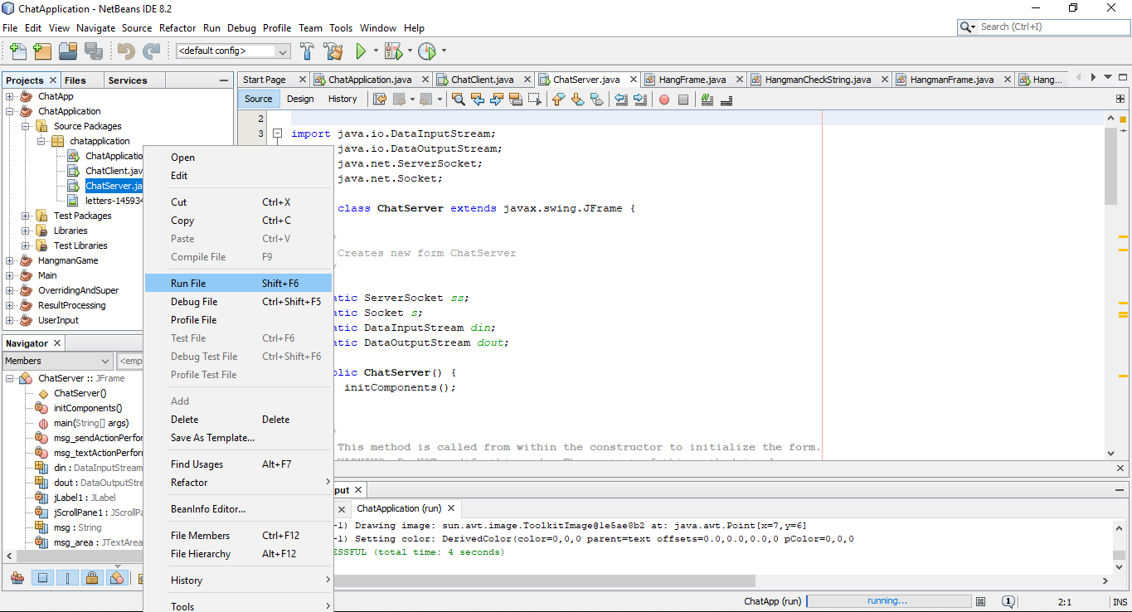From the project window, at first we select the ChatServer.java and choose the option-Run file. After running the project, it will work as the following images:

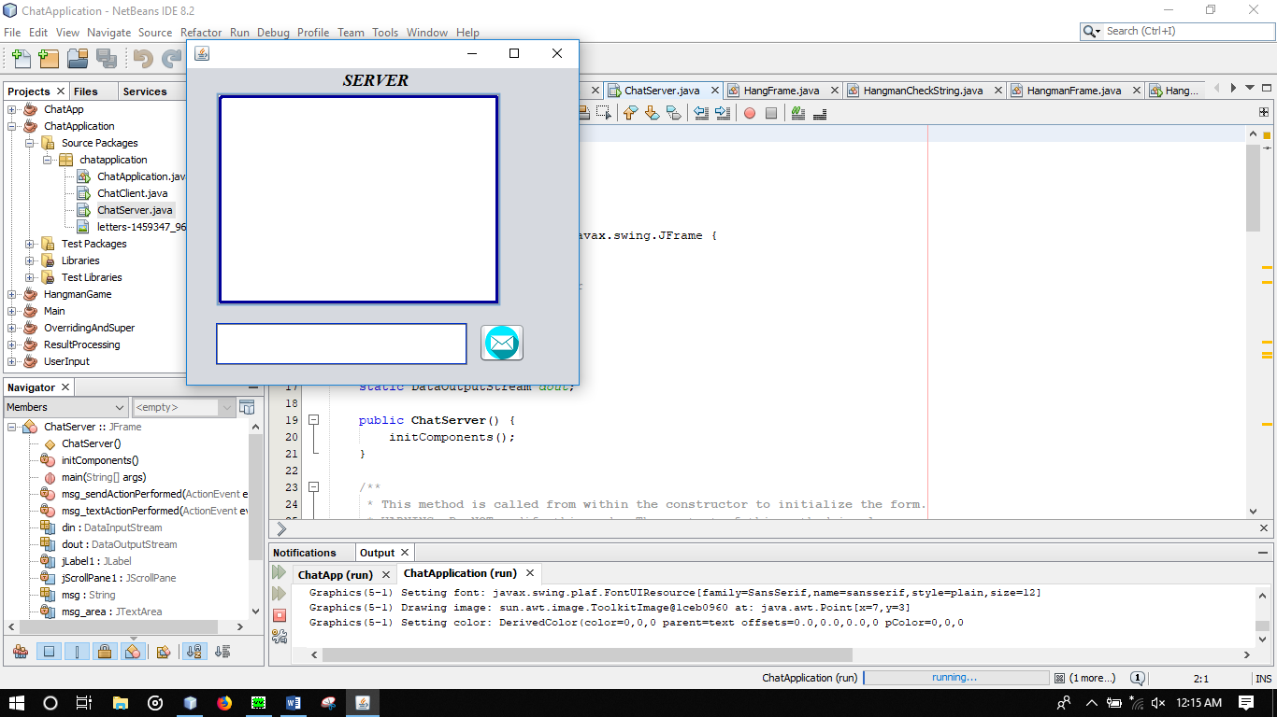

**Figure 2: Chat server window**

* In this figure we can see the screen after running the server. After that, we shall run the Chat client window to start the conversation.

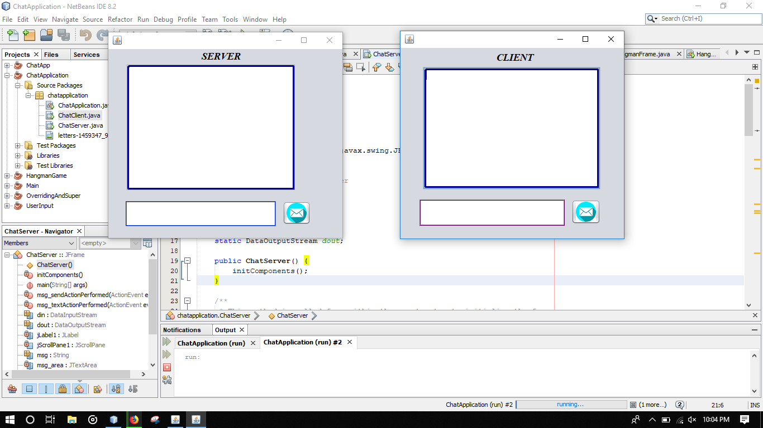

**Figure 3: Chat server-client window**

* In Figure 3, we can see that both the server and the client screen are displayed. So now the application is ready to start the conversation.

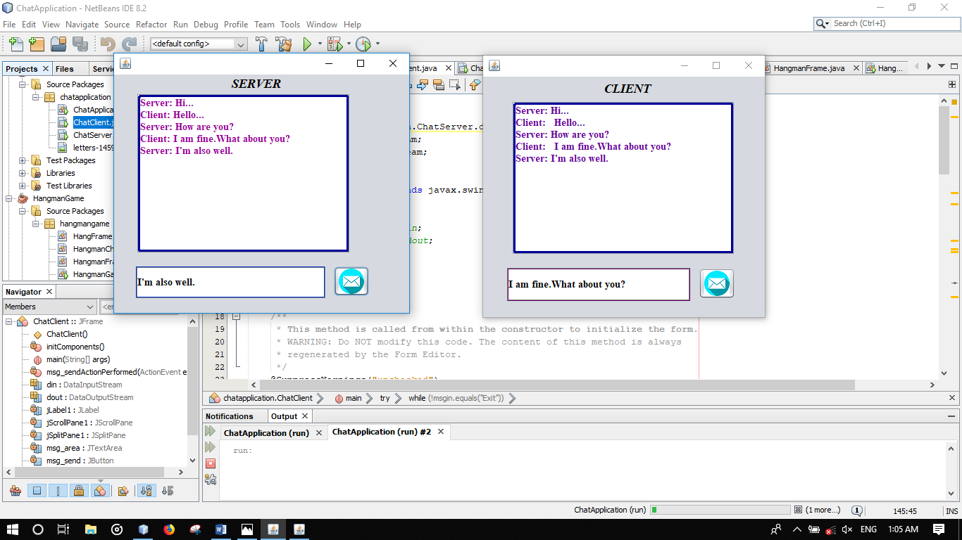

**Figure 4: Server-client conversation**

* In Figure 4, the message going from a client to the server are strings. Messenger destined for the server contains the string “***server*** “as the header and the client contains the string “***client*** “as the header. Client as well as server has to type the messages into the text field. After finishing the typing, sender has to click on the send button to send the messages to the receiver. The reader thread waits for incoming messages on the buffered stream. When a message arrives, the message string is printed on the console.

This is how the Client-server chat application works.